Welcome to the February / March edition of our Careers newsletter
for Students, Staff and
Parents, Carers, and Families.
Including
Online events for parents and students on options after GCSEs page 2

NHS Careers with the Royal Wolverhampton NHS page 3

Fred from First Dates talking about Careers in Hospitality page 4

Highlights from the Creative Industry Week - including advice and lots of opportunities

Birmingham UCAS Exhibition details page 5

Some ideas of where to look for Apprenticeships

LMI in Construction in the Black Country page 6

Stem opportunities page 7

Numeracy day

28th March – Life after GCSE’s – what are your child’s options? – 5.30pm – 6.15pm
Parent Information session – Exploring post 16 options – Life after GCSE’s

- Helping to explore all post 16 option available to your child
- Explore Sixth form route
- Explore Further Education College route
- Explore apprenticeships and Traineeships
- The sessions will explain the differences between A levels, T Levels, Technical and vocational pathways

Microsoft Teams meeting - Join on your computer or mobile app -
Click here to join the meeting

29th March from 10am -12noon for SEND pupils and parents

- https://learnliveuk.com/partner/black-country-local-enterprise-partnership/
The session can also be accessed on demand afterwards for schools to utilise at a later date . The broadcast is all around skills, what are they and how they develop them .

The broadcast and will Include…

- What are skills? , a broad overview of 12 key skills and a deeper look at – Focus and Attention, Understanding Instructions and teamwork
- Dan Noon – An employee of Network rail who is autistic , has Asperger’s and learning difficulties’ will discuss his skill development
- Ian Bird, Mark Berry and Sam Willis from Cadent Gas will discuss how Dyslexia and ADHD benefits them in the workplace and in his day to day life
- What are skills? – A deeper look at upholding behaviours , Resilience and Expressing yourself
- Greg Silvester – An employee of Trinity who has learning difficulties’ will discuss his skill development
- What are skills? – A deeper look at solving problems, keeping deadlines and using initiative
- from Cadent Gas will discuss how his Dyslexia and ADHD benefits him in the workplace and in his day to day life
- DPD supported interns will discuss what skills they use day in day out in their job
- Abbie Hare from Cadent Gas will discuss how her Dyslexia benefits her in the workplace and in her day to day life
- What are skills? – A deeper look at Learning from mistakes, Listening and setting goals

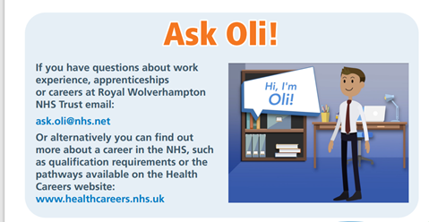

Hospitality is the UK's 4th largest industry and employs 4.5 million people – one in six jobs created is in hospitality. The broad hospitality sector covers everything from bars, hotels, coffee shops, contract catering, nightclubs, visitor attractions, escape rooms, bowling alleys, independent and large multi-national sites as well as cruise ships, festivals, and events.
As such the job roles and skills needed are extremely broad, ranging from chefs and waiters to marketing, events, interior designers and beyond.
There are many vacancies in this Sector in the Black Country

My Hospitality Life with Fred Sirieix

https://youtu.be/6Oe7nOPrsC4

Highlights from the Creative Industry Week - giving lots of ideas for Careers Pathways in this area and also ideas for
Visits and the Classroom activities – copy the link below and register

learnliveuk.com/black-country-creative-industries

UNIVERSITY

Booking Now

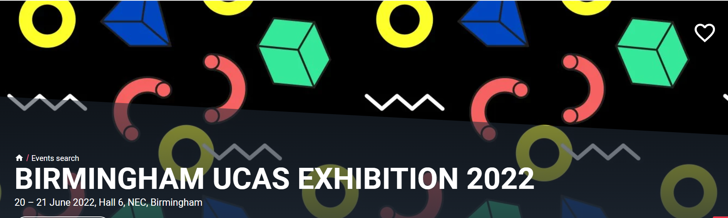

Many Level 2 and 3 Apprenticeships starting to appear now for September – some examples of where to apply in our area

www.gov.uk/apply-apprenticeship
About Us - In-Comm Training and Business Services
Contact Us : PTP (ptp-training.co.uk)

Details of apprenticeship opportunities (see attached) via the BBC Apprenticeship Hub at Level 3 so suitable for 17-18+. There are 3 schemes still open with a week left to apply, so the deadline for getting applications are very tight.
- Data Driven Professional; Level 3; September 2022; 16 months; Closing date to apply Friday 25 March
- Media Production Coordinator; Level 4; September 2022; 20 months; Closing date to apply Friday 25 March
- Software Developer; Level 4; September 2022; 18 months; Closing date to apply Friday 25 March

a presentation of the above

https://we.tl/t-SD12aBd1kM
Labour Market information in Construction in the Black Country
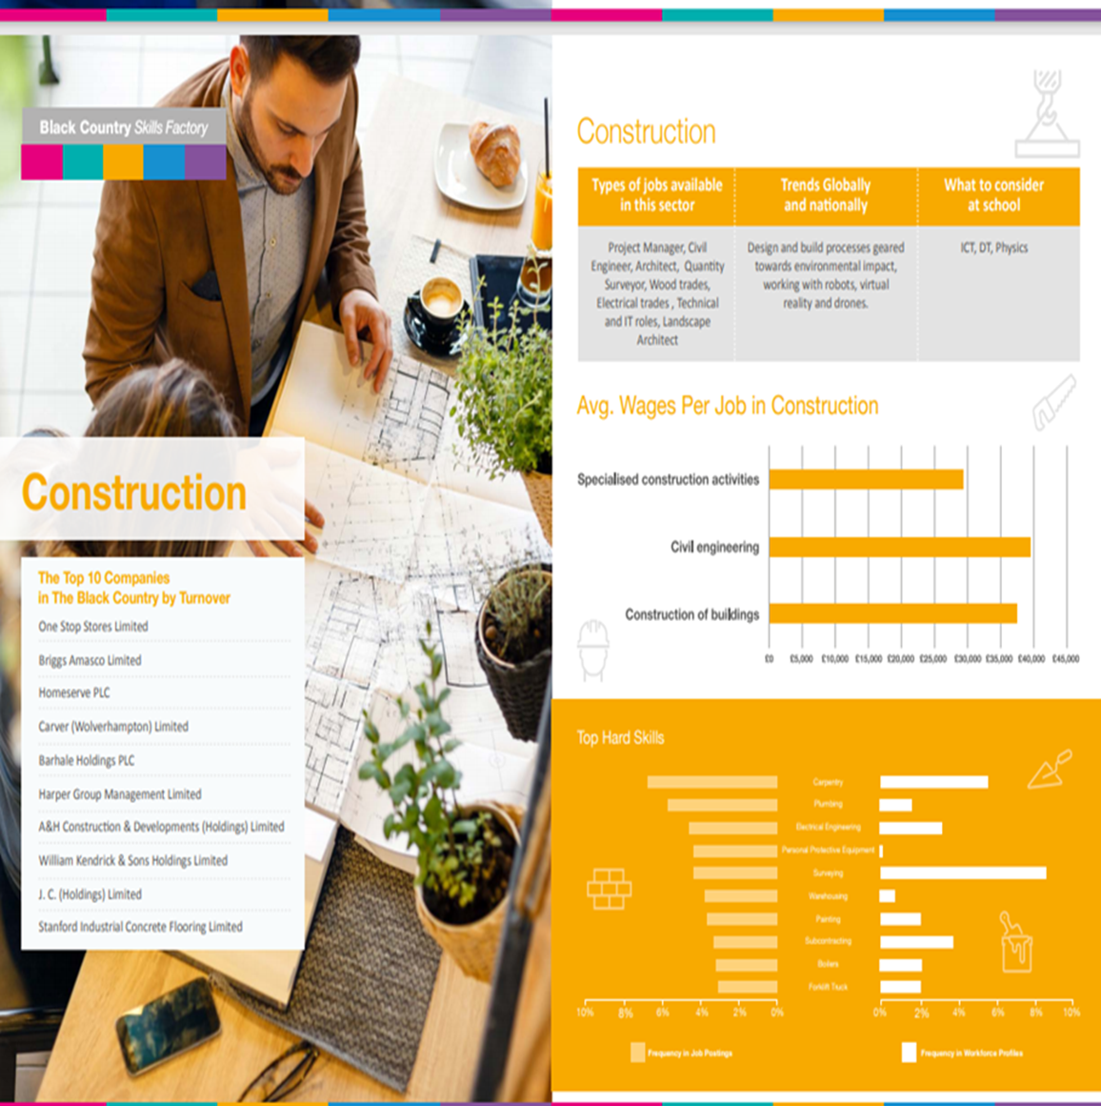
Other useful Information from the Black Country Careers Hub

STEM Events

STEM Learning Teaching Awards & STEM Inspiration Awards are now open for nominations!
Teachers. Technicians. STEM Ambassadors, Employers Partnerships! Nominate someone who has made a difference and give them the recognition they deserve. https://www.stem.org.uk/stem-learning-awards-2022
Secondary
Virtual TeachMeet West Midlands 28th March, 4.30pm – 6pm (rescheduled)
Join other teachers and hear speakers from the world of Data Science and the journeys students can take to enter the sector. Ask the experts your questions, network with local teachers and leave with information to link to lessons and share with students. Book your free place now: https://amsp.org.uk/events/details/9503
Subject: National Numeracy Day 2022 – Get Involved

We wanted to let you know about an exciting opportunity to get involved in National Numeracy Day 2022 and have colleagues from KPMG, come and support you with a ‘Numeracy at work’ panel as part of their National Numeracy Day celebrations during the month of May. Please see next page for more information and I hope that you will get involved in what will be a fantastic campaign.

National Numeracy Day 2022
KPMG are delighted to be the Founding Supporter of National Numeracy Day, the UK’s only annual day dedicated to everyday maths. When supporting children, brushing up on our own number confidence and skills can help. This year, it’s National Numeracy Day’s 5th birthday on Wednesday 18th May and we will focus on helping the nation to recover from Covid-19 and be empowered to move forward.
Get involved!
Become a Champion
Thousands of schools are signing up to be #NationalNumeracyDay Champions. Sign up to get your free digital pack of resources and activities, including an amazing competition for your school.
Sign up as a Champion
Host a Numeracy at Work Panel with KPMG volunteers
Our volunteers would love to come and answer your students’ questions about using numbers in their work and life. The format is flexible (in-person, virtual, pre-recorded video or written) and support resources are provided. This will be a fantastic opportunity to engage students with their careers and aspirations using numeracy and we would be delighted to have your school on board.*
Sign up for a Panel

